day 5-c programming

1. Implement a recursive program to calculate the power of a number.

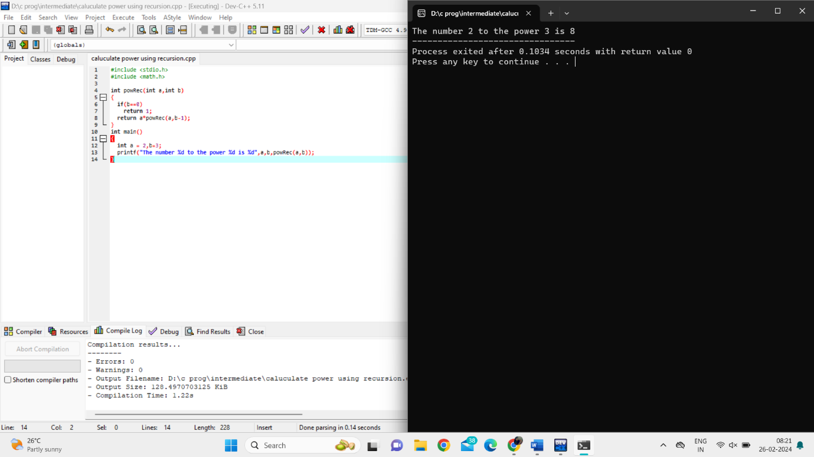

1. Write a program to recursively calculate the GCD (Greatest Common Divisor) of two numbers.

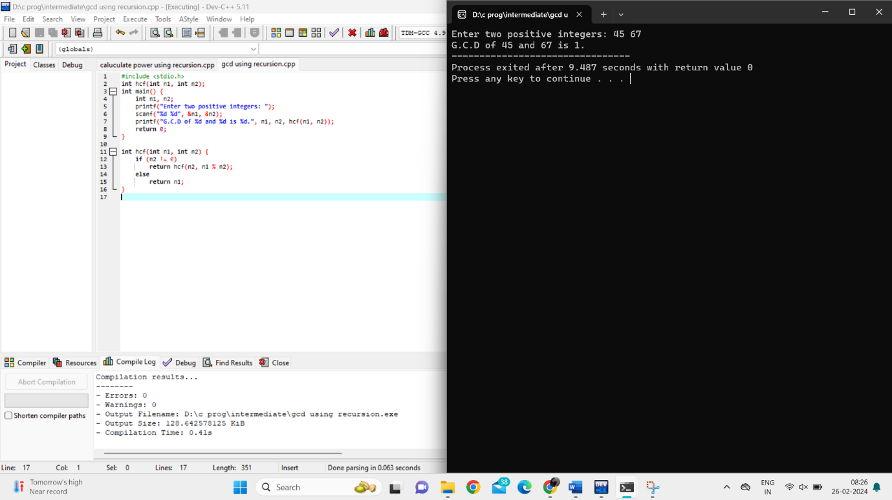

1. Implement a recursive program to find the sum of elements in an array.

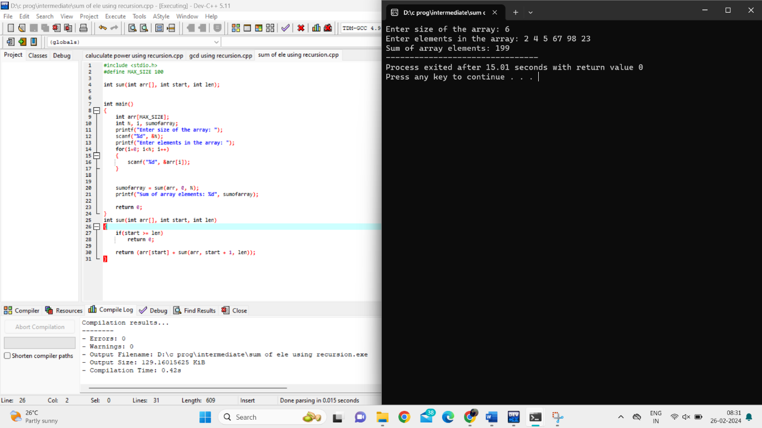

1. Write a program to recursively check if a given string is a palindrome.

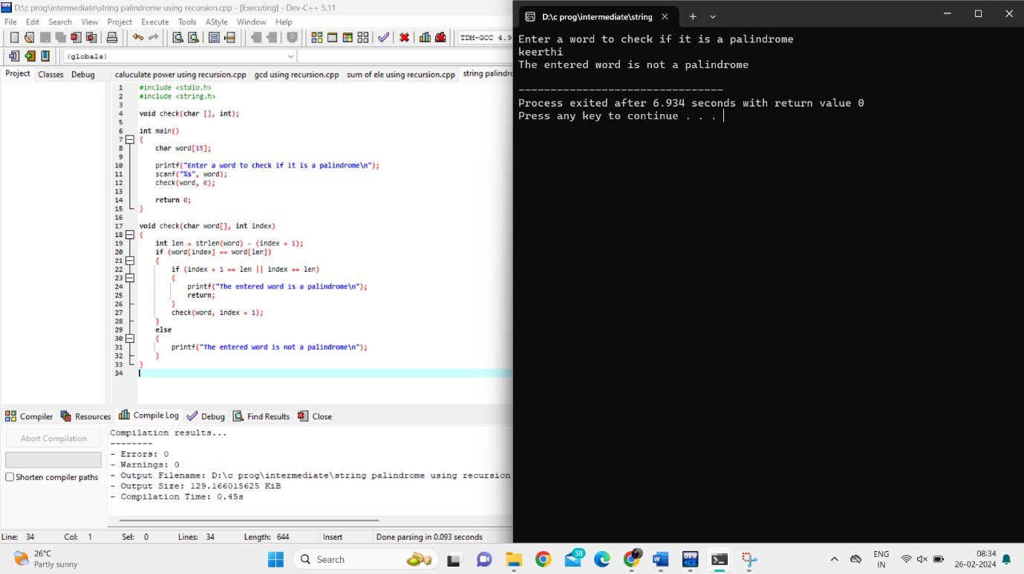

Implement a recursive program to reverse a string.

